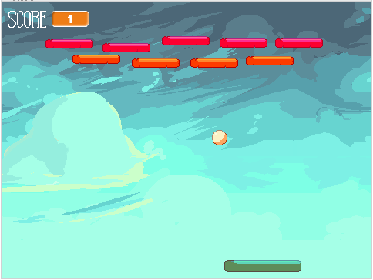

Tutorial - Atari Breakout

# Scratch

## Importing Assets

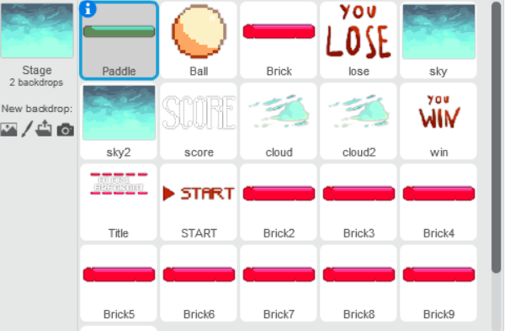

**Sprites:**

You will need to download the sprite assets provided in the repository.

You will have:

* 1 Paddle
* 1 Ball
* 3 Bricks
* 1 Sky sprite/background
* 1 Cloud sprite
* 1 Score sprite
* 1 Lose sprite
* 1 Win sprite
* 1 Title Sprite
* 1 START sprite

**Sounds:**

Sound files will also be included in the repository.

You will have:

* 1 Win sound effect
* 1 Lose sound effect
* 1 Chiptune music
* 1 point sound effect
* 1 block hit sound effect

## Start

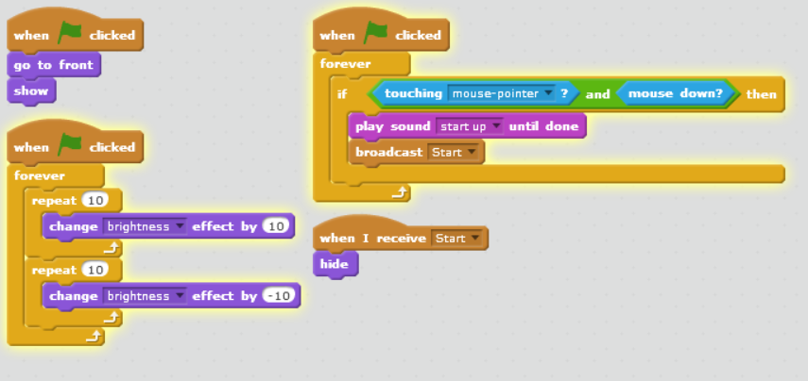

1. In the backdrop, import ‘sky’ image.
2. Import the START sprite as a new sprite:

AwJQPn.jpg

1. Import the ‘start-up’ sound into the Sounds tab on the right..
2. ‘When green flag clicked, go to front, show’ The start button is visible from the beginning
3. ‘When green flag clicked, forever, repeat 10 change brightness effect by 10, repeat 10 change brightness effect by -10’ this will cause the button to flash
4. ‘When green flag clicked,forever, if touching mouse pointer and mouse down, then play sound start up until done, broadcast start’ When the start button is pressed the start up sound is played and the game starts
5. ‘When I receive start, hide’ once the game has begun the button is no longer visible to the user.

## Title

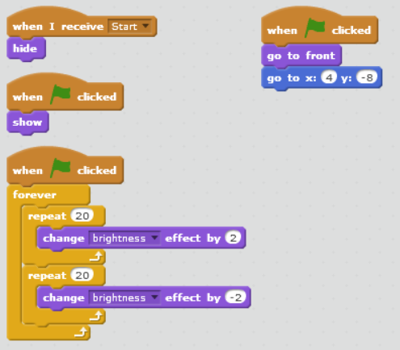

1. Import the ‘Title’ sprite as a new sprite.
2. ‘When green flag clicked, show’, ’When green flag clicked, go to front, go to x:4 y:-8’, The user sees the title in this position each time they open the game.
3. ‘When green flag clicked, forever, repeat 20, change brightness effect by 2, repeat 20, change brightness effect by -2’, This makes the title blink.
4. ‘When I receive start, hide’ Once the game starts the title will no longer be visible.

## Paddle

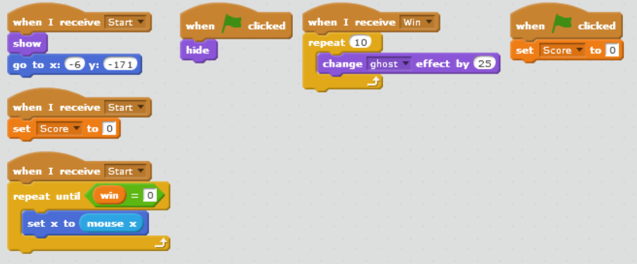

1. Import the ‘Paddle’ sprite as a new sprite.
2. Create a ‘Score’ variable, and a ‘win’ variable. The win variable will act as an indicator of whether the game has finished, or is playing.
3. ‘When green flag clicked, hide’, The paddle won't be visible during the title screen
4. ‘When green flag clicked, set score to 0’, ’When i receive start, set score to 0’ , this ensures that a new game is started
5. ‘When i receive start, show, go to x:-6 y:-171’ this starts the paddle in the bottom centre of the screen
6. ‘When i receive starts, repeat until win=0, set x to mouse x’, when the game starts the paddle will follow the mouse on the x axis for the user to control

page break

## Ball

1. Import the ‘Ball’ sprite as a new sprite.
2. Import Block sound effect.
3. When I receive ‘Start’, constantly keep checking if y position is less than -160, if so, broadcast Lose, and then stop this script.
4. When I receive ‘Start’, set win to 1.
5. When I receive ‘Win’, set win to 0.
6. When I receive ‘Lose’, set win to 0.(this sets up a value to check if the game is finished or running)
7. ’When I receive start, point in direction pick random 320 to 340, go to x: pick random -220 to 220 y: pick random 10 to -50, wait 0.5 secs’ This sets the ball in a non intrusive area and gives a delay for the user to react to the initial position of the ball’
8. ‘Repeat until win = 0’ The following will happen until the user wins
9. ’Move score/1.6 + 6 steps’, each time the user scores a point the ball will move faster, but the change will be gradual.
10. ‘If on edge, bounce’ the ball will bounce back on all walls as of now
11. ‘ If touching paddle, then point in direction , direction * -1 + pick random 175 to 185’ , whenever the ball hits the paddle it will bounce back and ever so slightly change direction in case it gets caught in a loop between blocks.

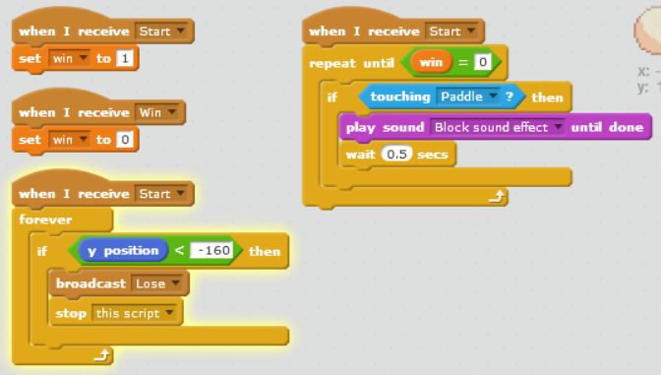

1. ‘When I receive start, forever, if touching brick or brick 2 etc, point in direction, direction * pick random -0.9 to -1.1 + pick random 175 to 185’ whenever the ball hits any of the bricks listed, it'll will bounce back with a slight varying degree incase the ball gets caught in a loop.
2. ‘When i receive start, repeat until win = 0, if touching paddle then play sound block sound effect until done, wait 0.5 seconds’ When the user is playing, there will be a hitting sound for when the ball hits the paddle until they win
3. When i receive start, forever if y < -160 then broadcast lose, stop this script’ Once the ball hits the bottom edge of the screen, the user receives the losing screen and the game ends.
4. ‘When i recieve win, set win to 0’ This triggers the Win sprite.
5. ‘When i receive start, set win to 1’ The win screen is triggered only when win is equal to 0.

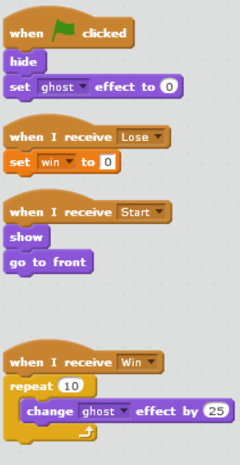

11.) ‘When green flag clicked, hide, set ghost effect to 0’ the ball isn't visible in the beginning, but shouldn't be transparent

12.) ‘When i receive lose, set win to 0’ this ensures that the user doesn't receive the win screen when they lose

13.) ‘When i receive start, show, go to front’ the ball is seen when the game starts

14.) ‘When i receive win, repeat 10, change ghost effect by 25’ This will cause the ball to fade out when the user wins.

## Backdrop

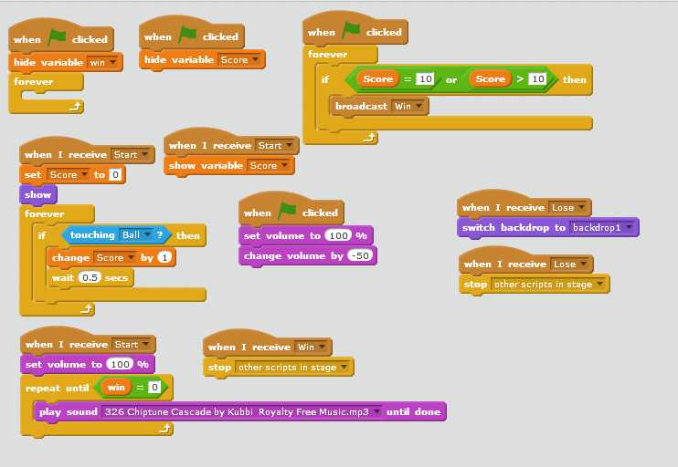

1. 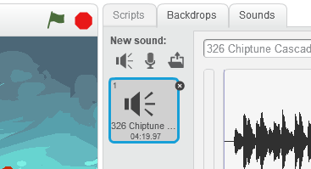

In the Sounds tab, import “326 Chiptune Cascade by Kubbi Royalty Free Music.mp3”.

3.) When ‘FLAG’ clicked, each the variables: win and Score will be hidden from view.

4.) When ‘FLAG’ clicked, Scratch will constantly check if the score is greater than, or equal; to 10.

## 

## Brick

1. Import the ‘Brick’ sprite as a new sprite. Add the other two sprites as costumes.
2. Import coin sound effect.
3. ‘When the green flag is pressed, the brick is hidden’ The interactive bricks are introduced after the title screen, so they should not be visible yet.
4. ‘When I receive Start, set score to 0’. This prompts a new game.
5. ‘Forever, if touching Ball the change Score by 1, and wait 0.5 secs’. Once the brick is hit, the player gets a point. They delay ensures that it is one point and not multiple.
6. ‘When i receive Start, forever, if touching Ball then wait 0.1 seconds, then play coin until done’ This acts as a reaction that tells the user they've successfully hit the brick.
7. ‘Repeat 10, Change brightness effect by 10’. This will make the brick lighten into nothing once it's been hit by the ball.
8. ‘Repeat 10, Change ghost effect by 10’. This makes the brick fade into nothing once it's been hit by the ball.
9. ‘Wait 0.01 secs, hide’ This ensures that the brick cannot be hit by the ball again
10. ‘When i receive start, show, go to front, switch costume to brick4’ . The brick becomes visible once the game has started. The costume should be changed to which color is prefered for the individual block.
11. After completing the code, duplicate the brick until you have as many as you need. You will need to go back to ball sprite, and edit the code with the large green block to include a sensing block for contact with each new sprite you made. You may also drag and drop the blocks where you see fit, and change the code for which costume they are set to.

page break

## Sky 1 and Sky 2 (optional)

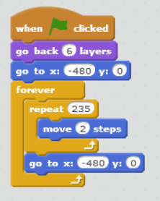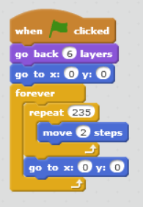

1. Import the sky sprite as a new sprite twice, and create the code for each (image 1 for sky1, and image 2 for sky 2)
2. This gives the illusion of a scrolling screen.

page break

## Cloud 1 and Cloud 2 (optional)

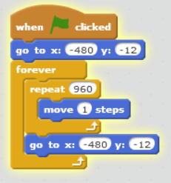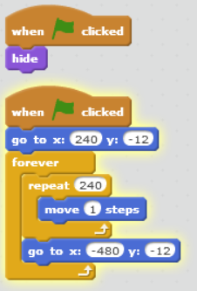

1. Import the cloud sprite as a new sprite twice, and create the code for each (image 1 for cloud1, and image 2 for cloud 2)
2. This serves as clouds passing in front of the sky background

page break

## Score (optional)

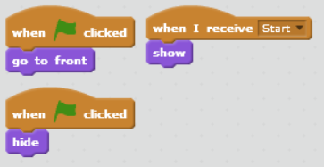

1. Import score sprite as a new sprite
2. Placed next to the numerical score variable to label what it is to the user. (double click on the score variable in ame until it changes appearance to just a number in a box, and place it next to the score sprite in the game window)

page break

## Lose

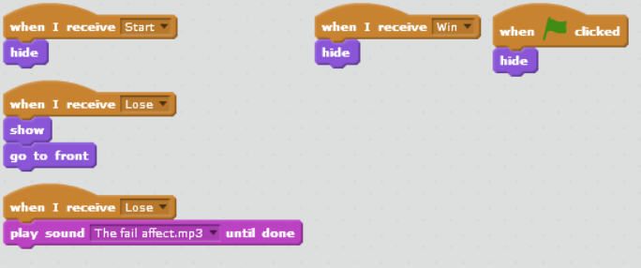

1. Import Lose sprite as new sprite.
2. Import The fail sound effect
3. ’When I receive start, hide’, ‘When i receive win, hide’, ‘when green flag clicked, hide’, This sprite should not be visible at all until the user loses
4. ‘When I receive lose, show, go to front’, When the user loses the message is received.
5. ‘When I recieve lose, play sound The fail affect.mp3 until done’, serves as audio feedback to confirm that the user has lost the game.

page break

## Win

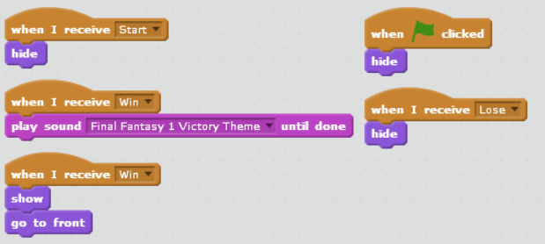

1. Import Win sprite as new sprite.
2. Import Victory theme.
3. ’When i receive start, hide’, ‘When i receive lose, hide’, ‘when green flag clicked, hide’, This sprite should not be visible at all until the user wins.
4. ‘When I receive win, show, go to front’, When the user wins the message is received.
5. ‘When I recieve win, play sound Final Fantasy 1 Victory Theme until done’, serves as audio feedback to confirm that the user has won the game.

page break